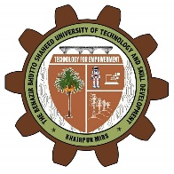
THE BENAZIR BHUTTO SHAHEED
UNIVERSITY OF TECHNOLOGY AND SKILL DEVELOPMENT
KHAIRPUR MIRS

Final Semester Examination-2024

Discipline  (Batch) | Semester /  Year | Course and Course Code | Instructor | Date | Credit  Hour | Time  Allowed | Total  Marks
MS CET  (01) | 1st /  1st | Advanced Civil Engineering Materials (CET-511) | Dr. Sadam Hussain | 17.05.24 | 3 CH | 03 Hours | 60

NOTE: Attempt all questions

Question No. |  |  | Marks
Q. 01 | (a)
 | (b)
Q. 02 | (a)
 | (b)
Q. 03 | (a)
 | (b)
Q. 04 | (a)
 | (b)
Q. 05 | (a)
 | (b)

The End

